

BY REQUEST

Welcome! Your empirically determined ideal work of art is just a few short pages away.
Answer the following questions as openly and honestly as possible. Thanks for your time!

I. Getting To Know You, Part 1: Generally Speaking (multiple choice)
From the four options provided, select the one that best completes each statement.

1. I think that collectors should buy works of art in order to
□ nurture young or emerging talents | □ preserve objects of great significance    or beauty
□ support challenging or innovative ideas | □ amass collections that represent    specific ideas about the trajectory of art

2. I learn best about art by
□ visiting the studios of artists and asking    questions | □ scrutinizing works of art alone—my    instincts are strong
□ talking to curators or art historians | □ reading articles or books

3. When reading glossy art magazines, I
□ look for opinion pieces or news on    hirings and firings | □ skip straight to the short exhibition    reviews in the back
□ turn to the interviews or to features on    museum shows | □ flip through the ads to get a sense of    what’s going on right now

4. I think museums
□ are places where great works of art go    to die | □ serve vital functions in educating the    public and preserving culture
□ can’t aspire to the dynamism and    creativity of the market | □ are the first place that aspiring artists    should look to discern what’s what

5. Museum “fluff” shows of works in private collections
□ are fine as long as proper    context/scholarship is provided | □  are necessary to get important    artworks into the public eye
□ are ethically suspect and generally    embarrassing | □  I am currently organizing one or more    fluff shows

6. Museum gift shops
□  trivialize the experiencing of canonical    works of art | □  are a nice way for the little people to    feel they’re participating in the creative    economy
□  are a great place to pick up notecards | □ are a great place to pick up ladies (of a    certain age)

7. The art blogosphere is
□ irrelevant thanks to Twitter | □  a place where idle chatter inflates non-    issues into scandals
□  a much-needed counterpoint to the    sluggishness and rigidity of the    mainstream art press | □  a giant crap fountain

8. At art fairs
□  everything important happens in the    first ten minutes | □  the social transactions are as    important as the commercial ones
□ I party like it’s 1999 | □  I feel an awful soul-sucking sensation

9. The biggest problem facing artists who live in D.C. is
□  the lack of exchanges between local    artists and museums | □  the relatively small collector base for    local art
□  the lack of legitimate local outlets for    visual arts criticism | □ the fact that they haven’t moved to    New York yet

10. I enjoy being a part of the D.C. arts community because
□  you can do whatever you want since    no one is watching | □  since it’s a relatively small pond, it’s    not difficult to get to know everyone
□  D.C. creatives are incredibly    passionate | □  I don’t live in D.C. (thank goodness)

II. Your Personalized Work of Art, Part 1: Either/Or
For each pair of descriptors, select your preferred term.

□ 2-D | □ 3-D
□ alchemy | □ science
□ alla prima | □ layered
□ Apollonian | □ Dionysian
□ austere | □ elaborate
□ autobiographical | □ impersonal
□ baroque | □ reductivist
□ buttery | □ chalky
□ carved | □ welded
□ celebrity | □ studio hound
□ chiaroscuro | □ color
□ choppy | □ smooth
□ clever | □ hardworking
□ collaborator | □ auteur
□ complementary | □ analogous
□ continuity | □ rupture
□ contrast | □ atmosphere
□ crafted | □ orchestrated
□ cross-disciplinary | □ medium-specific
□ deconstruction | □ pure presence
□ digital | □ analog
□ D.I.Y. | □ atelier
□ daring | □ accomplished
□ decorative | □ conceptual
□ domestic | □ public
□ drama | □ comedy
□ earnest | □ tongue-in-cheek
□ elitist | □ egalitarian
□ engaged | □ remote
□ environment | □ object
□ ephemeral | □ archival
□ existential | □ escapist
□ expanded field | □ back to basics
□ fact | □ fiction
□ face-mounted | □ matted and framed
□ figurative | □ abstract
□ figure | □ ground
□ found | □ rendered
□ freestanding | □ wall mounted
□ grandiose | □ unassuming
□ grit | □ polish
□ hand-drawn | □ computer-aided
□ hi-res | □ lo-fi
□ horror | □ suspense
□ humorous | □ moving
□ immediate | □ gradual
□ impasto | □ glaze
□ impetuous | □ methodical
□ inkjet | □ gelatin silver
□ intimidating | □ welcoming
□ juxtaposed | □ unified
□ large scale | □ miniature
□ M.F.A. | □ street-smart
□ masterful | □ raw
□ modeled | □ constructed
□ modern | □ postmodern
□ naked | □ nude
□ narrative | □ form
□ new media | □ oil on canvas
□ personality | □ self-subtraction
□ political | □ otherworldly
□ popular culture | □ art-as-art
□ post-colonial | □ western
□ print | □ original
□ project space | □ commercial gallery
□ promiscuity | □ inbreeding
□ rabbit skin glue | □ auto enamel
□ readerly | □ writerly
□ relational aesthetics | □ design aesthetics
□ research | □ intuition
□ right-brained | □ left-brained
□ seductive | □ repulsive
□ self-criticality | □ self-indulgence
□ single-minded | □ multi-valent
□ Socratic | □ didactic
□ studio space | □ laptop
□ theatrical | □ empirical
□ theoretical | □ heuristic
□ throwback | □ avante-garde
□ untested | □ traditional
□ urban | □ pastoral
□ vertiginous | □ steadfast
□ virtuous | □ sly
□ weathered | □ pristine
□ youthful | □ experienced
□ zeitgeist | □ anachronism

III. Getting to know you, Part 2: Your Art World Personality
Do the statements below accurately describe how you navigate the art world? Answer yes or no.

You almost never miss an important opening.
□ YES □ NO
You like works of art that challenge your beliefs.
□ YES □ NO
You appreciate many different types of artistic production.
□ YES □ NO
You feel involved when reading heated exchanges on art blogs.
□ YES □ NO
You are usually the first to react to a sudden event: the unexpected appointment of a curator or director or the opening of a controversial show.
□ YES □ NO
You are more interested in a general idea behind a piece than in the details of its realization.
□ YES □ NO
You tend to be objective about art even if this might jeopardize your relationships with others within the community.
□ YES □ NO
Strict observance of established good artistic practice is likely to prevent a good outcome
□ YES □ NO
It's difficult to get you excited about a new artist
□ YES □ NO
It is in your nature to get involved with the fate and finances of museums
□ YES □ NO
You often think about the forward trajectory of artistic discourse
□ YES □ NO
You are hesitant to commit to supporting an artist’s career
□ YES □ NO
Objective criticism is always useful in talking to artists
□ YES □ NO
You prefer to buy immediately rather than consider an artist’s possible stylistic evolution
□ YES □ NO
You trust art historical validation rather than novelty
□ YES □ NO
You are inclined to rely more on your immediate reaction to work than on research and reflection
□ YES □ NO
You spend your leisure time actively socializing with arts professionals, attending openings, etc.
□ YES □ NO
You usually plan your exchanges with arts administrators in advance
□ YES □ NO
Your art purchases are frequently influenced by emotions
□ YES □ NO
You are somewhat reserved and distant from other gallery goers
□ YES □ NO
You know how to put every minute at an art fair to good purpose
□ YES □ NO
You readily loan works to art exhibitions while asking nothing in return
□ YES □ NO
You often contemplate the complexity of art theory
□ YES □ NO
After prolonged time hobknobbing with artists, collectors, and dealers you feel you need to get away and be alone
□ YES □ NO
You often make your way through exhibitions in a hurry
□ YES □ NO
You easily see the general principle behind developments in the art market
□ YES □ NO
You frequently and easily express your preferences regarding works of art
□ YES □ NO
You find it difficult to be heard over others at a loud opening
□ YES □ NO
You get bored if you have to read Rosalind Krauss
□ YES □ NO
You tend to sympathize with struggling artists
□ YES □ NO
You value talent higher than persistence
□ YES □ NO
You rapidly get involved in socializing amongst newcomers to the art scene
□ YES □ NO
The more artists with whom you speak, the better you feel
□ YES □ NO
You tend to prefer artworks you’ve seen firsthand to alternatives seen in reproduction
□ YES □ NO
You like to keep a check on how a commissioned work of art is progressing
□ YES □ NO
You easily empathize with the concerns of museum professionals
□ YES □ NO
Often you prefer to listen to the podcast than actually attend a panel discussion
□ YES □ NO
You enjoy being acknowledged in a show organized by others
□ YES □ NO
You are more inclined to experiment with unknown artists than to acquire blue-chip pieces
□ YES □ NO
You avoid being bound by obligations to museum boards
□ YES □ NO
You are strongly touched by stories about artists’ foibles
□ YES □ NO
Prices for artworks seem to you to be of relative, rather than absolute, importance
□ YES □ NO
You prefer to isolate yourself from noisy openings
□ YES □ NO
It's essential for you to try an artistic process with your own hands sometimes
□ YES □ NO
You think that almost any artwork can be analyzed
□ YES □ NO
You do your best to complete a catalogue essay on time
□ YES □ NO
You take pleasure in putting your collection in order
□ YES □ NO
You feel at ease in the thick of the Armory Show
□ YES □ NO
You have good control over your desires and temptations to buy every artwork you see
□ YES □ NO
You easily understand articles in October
□ YES □ NO
The process of learning about new artists is more important to you than owning their work
□ YES □ NO
You usually place yourself nearer to the side than in the center of a gallery
□ YES □ NO
You would rather acquire historically validated works than hot new contemporary ones
□ YES □ NO
You try to stand firmly by your aesthetic judgements
□ YES □ NO
A thirst for challenging new art is close to your heart
□ YES □ NO
You prefer meeting an artist face-to-face rather than reading her or his artist’s statement
□ YES □ NO
When considering an exhibition you pay more attention to an artist’s current body of work and less to the shape of her or his career arc
□ YES □ NO
You consider the scientific approach to be the best in the studio
□ YES □ NO
You find it difficult to talk about your feelings about your favorite artworks
□ YES □ NO
You often spend time thinking of how the installation of a particular show could be improved
□ YES □ NO
Your evaluations of a show are based more on the feelings of a moment than on extended reflection
□ YES □ NO
You prefer to spend your leisure time alone or relaxing in a tranquil sculpture garden
□ YES □ NO
You feel more comfortable around Washington Color School paintings
□ YES □ NO
You are easily affected by images depicting emotional experiences
□ YES □ NO
You are always looking for opportunities to see new art
□ YES □ NO
Your art storage space/desktop is usually neat and orderly
□ YES □ NO
As a rule, the contents of a museum’s permanent collection interest you more than the arrival of a traveling show
□ YES □ NO
You get pleasure from walking through museum collections alone
□ YES □ NO
It is easy for you to communicate during gallery talks
□ YES □ NO
You are consistent in your art buying/viewing habits
□ YES □ NO
You willingly involve yourself in fundraisers for organizations with which you sympathize
□ YES □ NO
You easily perceive various ways in which an artist’s career could take off
□ YES □ NO

IV. Your Personalized Work of Art, Part 2: Media Matters (multiple choice)
From the four options provided, select the one that best completes each statement.

11. When I look at works of art featuring images of the naked human body, I
□ feel that the artist is relying on a tired    trope | □  become aroused
□ try to establish if the artist is    empowering or objectifying his subject | □  try to imagine that the body is simply a    collection of planes and angles

12. Color is
□ something I respond to emotionally,    intuitively | □ strictly for simpletons
□ what makes art stylish and fun | □ fine as long as it’s in the service of an    idea

13. I like photographers who
□ exhibit mastery of traditional or even    cantankerous old processes | □ create staged, choreographed images    to question our expectations re: the    veracity of photographic images
□ treat the camera as a tool at the service    of performance or installation | □ create spectacular, hyperreal images    that make the mundane appear exotic

14. Painters should use paint to
□ communicate narrative, history | □ show that no other medium can match    the seductive formal qualities of    traditional oils
□ lay bare the impossibility of doing    anything heroic, progressive, or truly    new with the medium | □ comment on photography

15. Video
□ works best as an extension/    documentation of performance | □ works best when it plays with    cinematic conventions
□ works best when it’s made by    Matthew Barney | □ works best when it’s not narrative-    driven, but is instead atmospheric

16. Political content in art
□ is usually a mistake, and cheapens or    dates the work | □ is fine as long as it’s not didactic
□ can be the most powerful kind of    content | □ all art is political, whether intentionally    or not

17. The artist’s personal experiences
□ are irrelevant to the work | □ should actively shape and be reflected    in the work
□ can serve as a trope with which to    misdirect or deceive the audience | □  are only interesting to the extent that    they reflect the action of larger forces    in the world—political, cultural, etc.

18. The best sculptors typically
□  use scale and spatial effects to    heighten viewers’ awareness of how    they locate themselves in space | □  create objects of intense refinement    that distill both the historical uses of a    given material and its physical    properties
□  create interventions within the natural    or built environment to alter the viewer’s    awareness of familiar sites | □  pursue a more performative, less    object-based practice

19. Performance art
□  hasn’t really advanced significantly as a    practice since the early 1970s | □  is difficult to document, present, or    collect, and is therefore off of my radar    screen
□  should only be re-presented through    reperformance, as Marina Abramovic    favors | □  should always incorporate nudity    somehow

20. I generally want art to
□ offer opportunites for solitary    contemplation of ideas and images | □  serve as a public forum that    challenges existing mores or    conventional wisdom
□  dazzle me with unexpected appeals to    my sensorium | □  exude the cool demi-monde vibe that I    love to cultivate

V. Your Personalized Work of Art, Part 3: Either/Or Redux
For each pair of images, select your preferred work of art.

□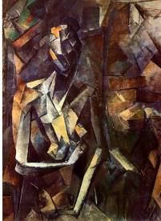 □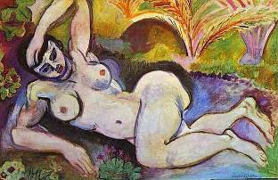

□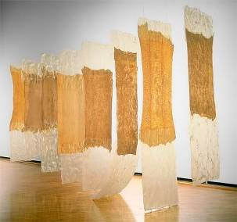 □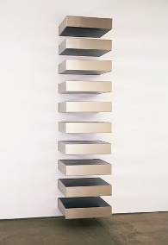

□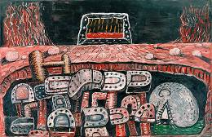 □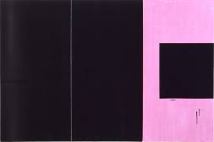
□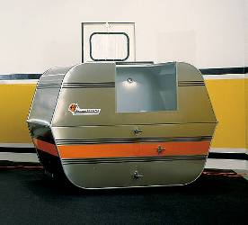 □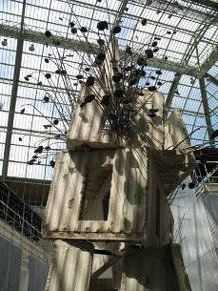

□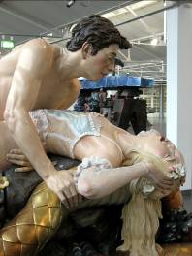 □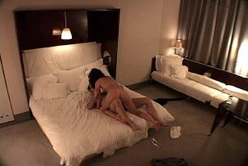

□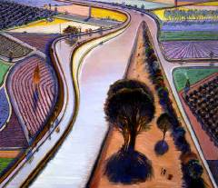 □

□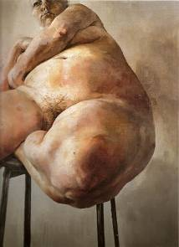 □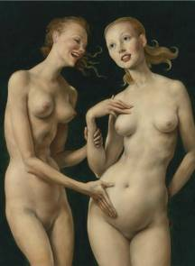

□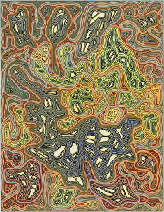 □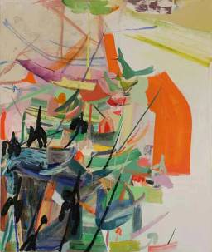

□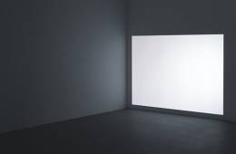 □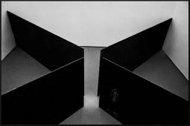

□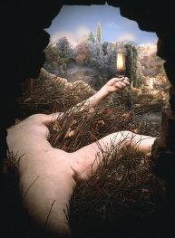 □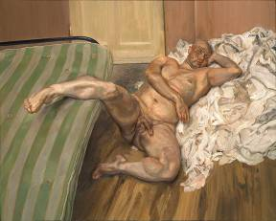

□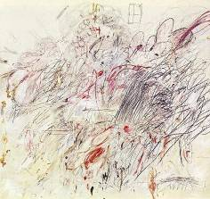 □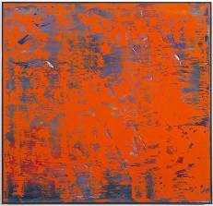

□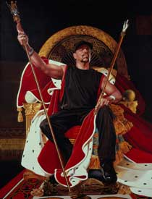 □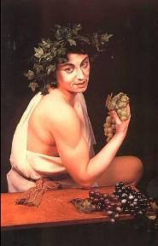
□ □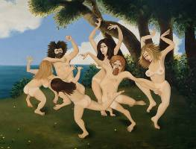

□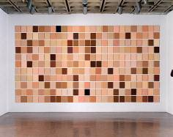 □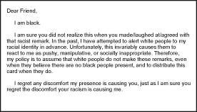

□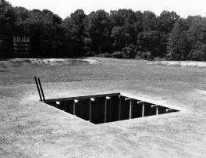 □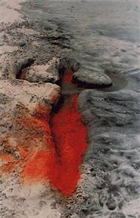

□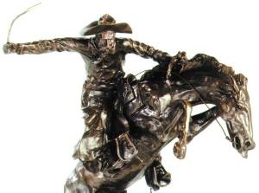 □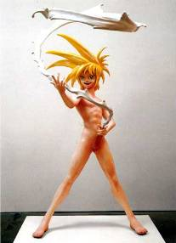

□ □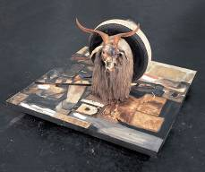

□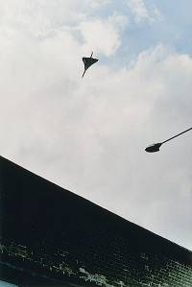 □
□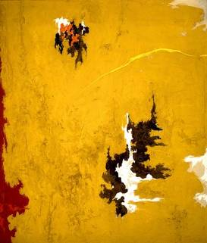 □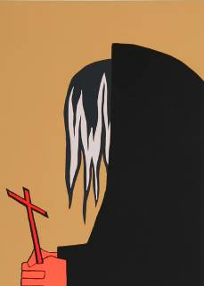

□ □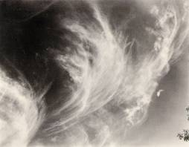

□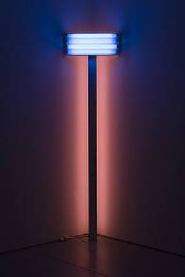 □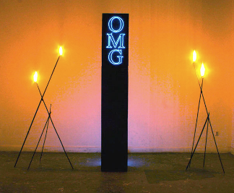
□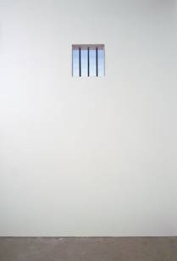 □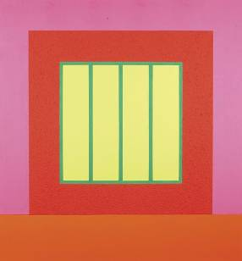

□ □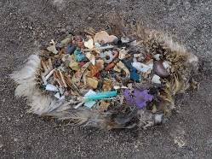

□ □

□ □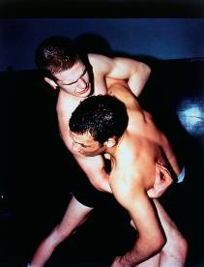

□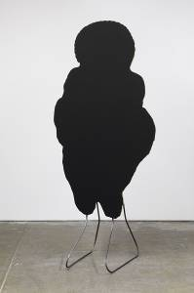 □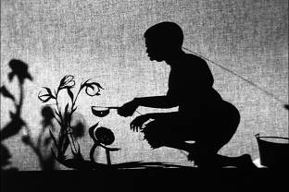

□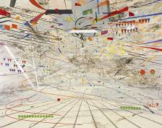 □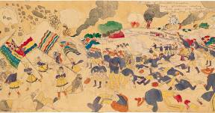
□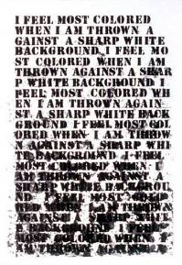 □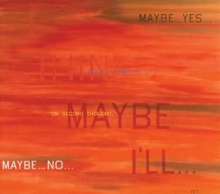

□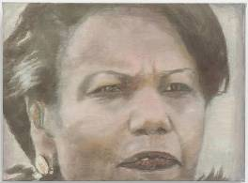 □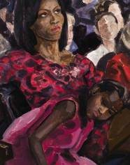

□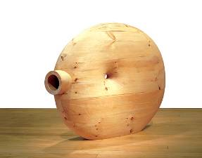 □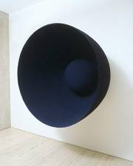

□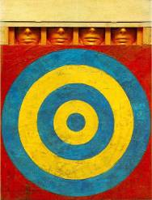 □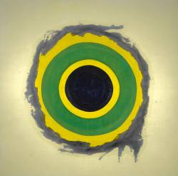

□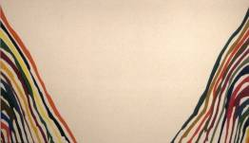 □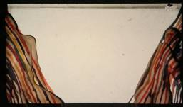

□ □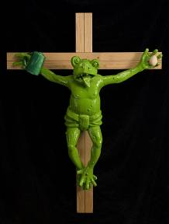

Congratulations! You have completed your BY REQUEST survey. Thanks for your participation. Please return this booklet in the enclosed envelope and prepare to experience your ideal artwork.

Existo curiosus quis vos opto: Vos iustus vires adepto is!
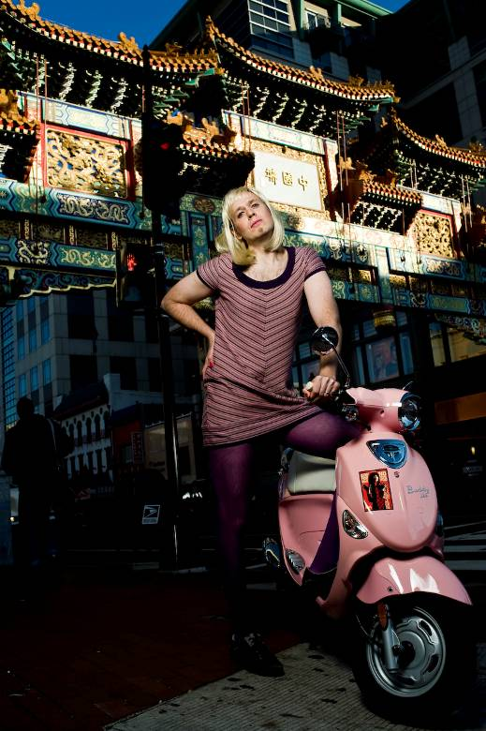

A Portrait of the Artist as Philippa Hughes, Joshua Cogan, 2009

